2024 Tour of East Taiwan
2024 Tour of East Taiwan 365km Challenge
The 2024 Tour of East Taiwan Cycling Series 365 km Challenge will be held on April 13th ~ 14th.

The event will be held over two days in East Taiwan. On Day 1, riders will ride along the Coastal Highway (No.11) and be able to experience the amazing scenery of the Pacific Ocean from Hualien to Taitung. On Day 2, riders will cycle along the No.9 highway to enjoy the landscapes of the East Rift Valley from Taitung back to Hualien. East Taiwan is the last remaining cycling paradise on the island thanks to the fact that it is neither highly urbanized nor industrialized. Participating in this challenge ride, you will enjoy spectacular views of the ocean and mountains along the way, meeting friendly people is another special experience. We sincerely invite you to join us!

Directed by: Sports Administration, Hualien County Government, Taitung County Government.
Organizer: Taiwan Cyclist Federation, Hualian County Athletics Federation.
Date: Apr.13th ~ 14th, 2022 (Sat. ~ Sun.)
Event on-site Check-in:
Apr.12th, 13:00 – 18:00 at Hualian Pacific Ocean Park.
Event Briefing: Apr.12th, 16:00 at Hualian Pacific Ocean Park.
Route & Schedule:
- Apr.13th : Hualien –Taitung via Taiwan No.11 highway(170km).Time allowance 11 hrs.
05:00~ Sign up & day bag transportation check-in. (Hualien Pacific Ocean Park)
06:10 Start: Hualien Pacific Ocean Park – Hualien Bridge – Nioushan Tunnel – Jiqi – Changbin – Tulik – Taitung City.
10:00 Lunch / Baxientong parking lot (79kms from start.)
17:00 Finish: Formosan Naruwan Hotel & Resort Taitung.
13:00~17:00 Daybag claim – at the hotel.
- Apr.14th : Taitung –Hualien via Taiwan No.9 highway(170km). Time allowance 11 hrs.
05:00~ Sign up & daybag transportation check-in. (Naruwan Hotel & Resort)
06:10 Start: Naruwan Hotel & Resort– Luyeh – Fuli – Wuho – Guangfu – Fenglin – No.11C – Pacific Ocean Park.
10:00~ Lunch / Guangfong Farmers’ Association
13:00~ Daybag claim – Hualien Pacific Ocean Park.
17:00 Finish: Hualien Pacific Ocean Park.
Rider Qualifications: Experienced riders able to cover long distance over 150km in a day.
Entry Fee: A-NT$2,500 per person; B-NT$4,000. A refundable chip deposit NT$500.
(A Tour of East Taiwan 210/160km Challenge event is available.)
Event Souvenir: A-Event shirt, cycling cap, bike plate, 2 finisher medals, day bag, digital finisher certificate, lunch, timing chip and number patch, feeding stations, basic insurance, day bag transportation and recovery vehicle service.
B-All items in A, plus event jersey(MSRP NT$2,500).
Optional order items of hotel reservation, and event souvenirs:
- Hotel rooms for 4/12 in Hualien and 4/13 in Taitung. 4/13 hotel room fare in Taitung includes buffet dinner / breakfast.
- Lion Travel Event Accommodation Package including railway return tickets starting from Songshan Station 10:30 on 4/12.
- Event souvenirs including jersey and T-shirt.
These optional items could be purchased via the registration webpage.
Timing Chip Deposit:
NT$ 500 per person (Deposit to be pre-paid in event registration. To be refunded when returning the chip at the finish. NT$1,000 penalty for each chip lost.)
Categories: All types of bicycles
- M15 – Age 15~19 ( 2005 – 2009）
- M 20 – Age 20 ~ 24（2000 – 2004）
- M 25 – Age 25 ~ 29（1995 – 1999）
- M 30 – Age 30 ~ 34（1990 – 1994）
- M 35 – Age 35 ~ 39（1985 – 1989）
- M 40 – Age 40 ~ 44（1980 – 1984）
- M 45 – Age 45 ~ 49（1975 – 1979）
- M 50 – Age 50 ~ 54（1970 -1974）
- M55 – Age 55 ~ 59 ( 1965 – 1969）
- M60 – Age 60 and above ( ~1964）
- W35 – Female Age 35 and under（1989 ~ 2007）
- W36 – Female Age 36 and above（~ 1988）
- Pedalec（Electric-assisted）: no age and gender limitation.
Registration:
- Online registration by visiting www.cyclist.org.tw and clicking into the event registration page. Online registration ends on Mar.10th.
- Payment: Following the registration webpage instruction, you may proceed to the credit card payment. For any order change, please kindly email us via service@cyclist.org.tw before Mar.10th. From Mar.11th on, any order change will NOT be acceptable.
Rules and Regulations:
      - Riders are only permitted to ride bikes with full braking system. The bicycle must be mounted with front and rear lighting for illumination when going through tunnels.
      - Riders must wear cycling jerseys and helmets at all times during riding.
      - Please make sure that your bike is properly maintained prior to the event and remember to bring your personal spare parts.
      - Please attach your event identification materials as shown below:

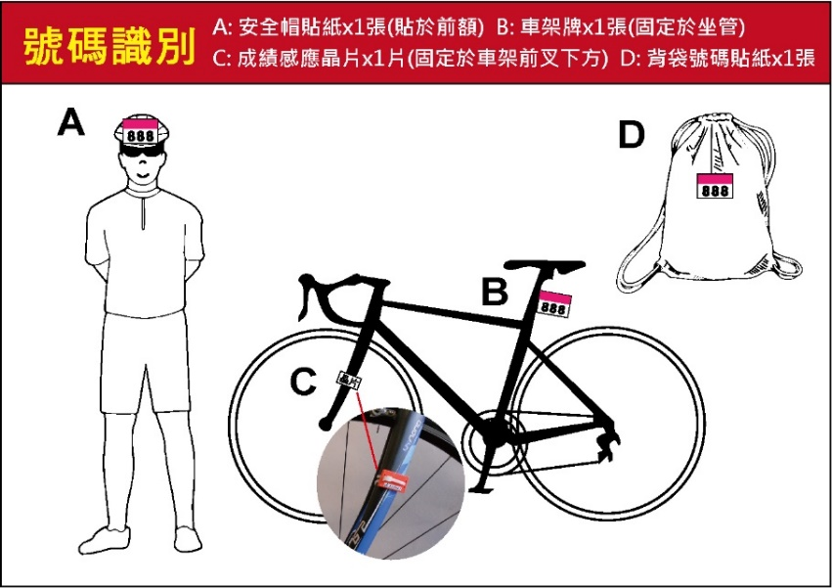

      - Riders must ride on the right side of road and obey traffic rules. Riding in the wrong direction/lane (left side) is prohibited.
      - There will be feeding stations every 25~45kms along the route. Riders should slow down and ride to the roadside to approach the feeding zone for taking feeding supplies.
      - Day bag claim:
- Apr. 13th – Please receive your transported day bag at the Formosan Naruwan Hotel & Resort Taitung upon your arrival.
- Apr. 14th – Please receive your luggage at Hualien Pacific Ocean Park.
- Please make sure each piece of your luggage has a clear and easy-to-read luggage tag for identifying your luggage.
- Please hand over your day bag to the Day Bag Transportation Car in time before you start the riding. Do NOT put valuables or fragile items in the day bag for transportation.
- We recommend you bring just one piece of luggage for the event. DO NOT hand over the hard-shell bike box to the day bag truck.
      - The rider insurance of this event is Public Liability Insurance, in which any personal health problem during the event or any riding injury caused by personal health problem will not be included in this insurance. Riders are recommended to buy personal health and medical care insurance.
      - Participants will be covered with the Travel Insurance and the Public Liability Insurance. The Public Liability Insurance covers the accident only that Organizer is responsible for. Each participant should evaluate his/her own safety regarding personal health conditions when deciding whether to participate in his event. Participants should apply for extra personal insurance policy at his/her own cost when considering that the aforementioned insurance is insufficient. Please refer to the Insurance Policy Website for the coverage details of the Travel Insurance and the Public Liability Insurance. The Organizer is only responsible for the indemnity amount with the maximum payment of claims per person as the insurance policy offers. Do not register the event if you do not agree with the coverage, items, indemnity amount of insurance policy.
      - According to the Insurance Law, riders under 15 years old would not be compensated with death indemnity under Life or Injury Insurance policy.
      - For the medical insurance needs, if any hospital medical treatment is caused by an event accident, keep all receipt and diagnosis certificates (issued by a doctor) and give these later to the Taiwan Cyclist Federation for insurance payment application needs.
      - This event is a physically challenging ride. Riders who have hypertension, cardiopathy, asthma, cardiovascular diseases, diabetes, epileptoid, are not recommended to join this event.
      - The Organizer has the right to stop riders from riding depending on the rider's health condition at any time before or during the event.
      - Riders with time chips installed must pass the time recording zone at the Start Point and at the Finish Point for official time recordings.
      - Depending on the weather or any natural disaster, the Organizer has the right to stop or cancel the event, with regards to concern for rider safety.
      - Riders shall not dispose of any rubbish throughout the route and event area.
      - The Organizer has the right to use any reports/articles and images of the event for promotional purposes.
      - Please watch for any information updates with regards to this event, which will be announced on the T.C.F. website: www.cyclist.org.tw & Facebook fans page: www.facebook.com/tcf1999.

Contact: Taiwan Cyclist Federation
Tel：+886-2-8919-3595 Fax：+886-2-8919-3311 E-Mail：service@cyclist.org.tw
Website: www.cyclist.org.tw Address: 1F, No.17, Lane 100, Chungxing Road Section 2, Xindian District, Xinbei City 231, Taiwan (R.O.C.)

Remark: the design is for reference and subject to change.

[ Feeding Station schedule ]
Apr.13th (Sat.) Hualien Pacific Ocean Park—Formosan Naruwan Hotel & Resort Taitung
Time | Feeding Station |  | Location | Accu.  dist. | Altitude | Est. 1st arrival |  | Closing  Time |  | Single-  stage  dist.
AM05：00 | Hualien Pacific Ocean Park |  | Luggage trans-portation.  Warm-up. | -- | -- | -- |  | -- |  | --
AM06：00 | Hualien Pacific Ocean Park |  | Event start. | 0 | -- | -- |  | -- |  | --
 | - Jiqi beach parking lot |  | Route 11-37K | 35 | 24 | AM07：00 |  | AM0：30 |  | 39
 | - Lunch at restaurant of Baxientong Parking lot |  | Route 11-77K | 76 | 16 | AM09：00 |  | PM11：00 |  | 40
 | - Roadside of Poai School |  | Route 11-103K | 102 | 30 | AM10：00 |  | PM12：30 |  | 26
 | - Fuan Temple |  | Route 11-147K | 149 | 54 | PM11：30 |  | PM16：00 |  | 47
 | Finish – Formosan Naruwan Hotel & Resort Taitung |  | Finish Medal.  Day bag claim. | 169 | 69 | PM12：30 |  | PM17：00 |  | 20
Day 1 distance : 170km |  |  |  | Estimated riding time : 7~11 hours
Apr.14th (Sun.) Formosan Naruwan Hotel & Resort Taitung— Hualien Pacific Ocean Park
Time | Feeding Station | Location |  | Accu.  dist. | Altitude | Est. 1st arrival | Closing  Time |  | Single-  stage  dist.
AM05：00 | Formosan Naruwan Hotel & Resort Taitung | Luggage trans-portation.  Warm-up. |  | -- | 69 | -- | -- |  | --
AM06：00 | Formosan Naruwan Hotel & Resort | Event start |  | 0 | 69 | -- | -- |  | --
 | - Luyeh District Office | Route 9-350K |  | 25 | 151 | AM06：50 | AM07：40 |  | 25
 | - Luoshan Cisitor Center | Route 9-295K |  | 64 | 273 | AM08：00 | AM09：30 |  | 39
 | - Wuho Tableland  (Tropic of Cancer) | Route 9-260K |  | 100 | 153 | AM09：30 | AM11：40 |  | 36
 | - Lunch at Guangfong Farmers’Association | Route 9-235K |  | 123 | 125 | AM10：30 | PM13：30 |  | 23
 | - Land Temple | Route 11C-16.5K |  | 146 | 157 | PM11：30 | PM15：00 |  | 23
 | Hualien Pacific Ocean Park | Finish medal.  Luggage claim. |  | 169 | 24 | PM 12：30 | PM 17：00 |  | 23
Day 2 distance : 170km |  |  |  | Estimated riding time : 7-11 hours

挑戰組活動路線圖Event Route Map

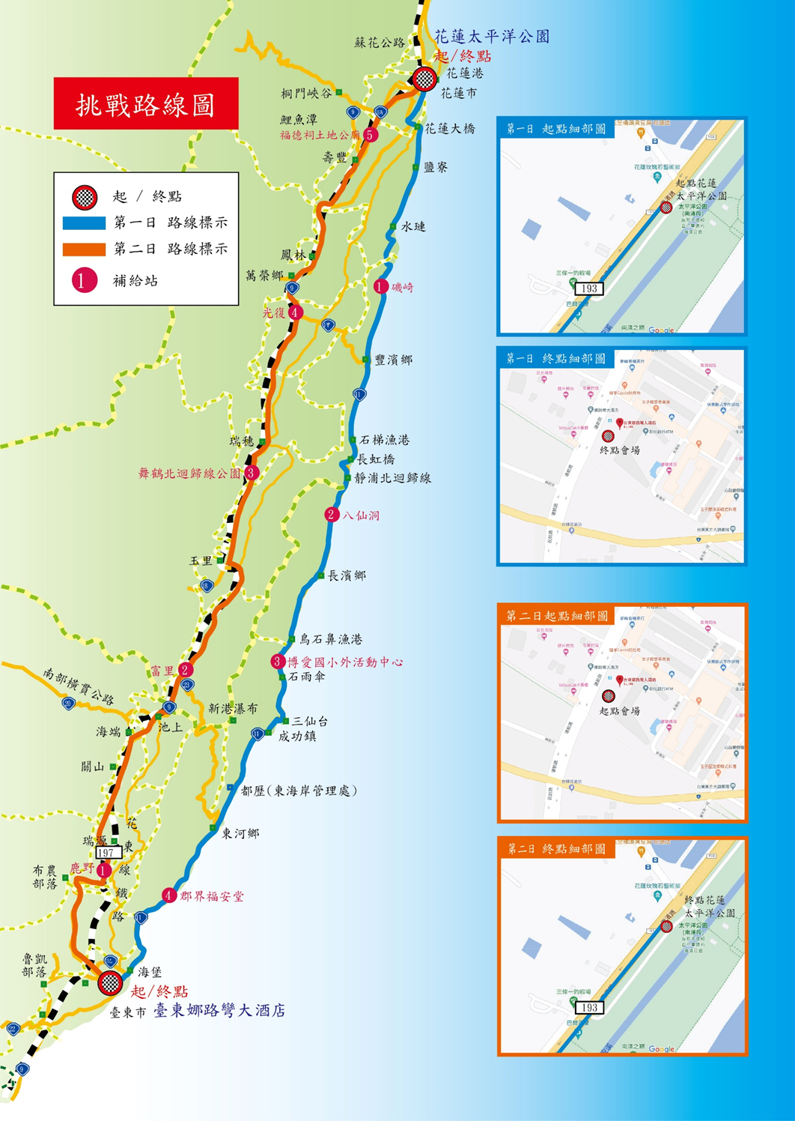

活動贈品：紀念衫示意圖Event Souvenir - Shirt
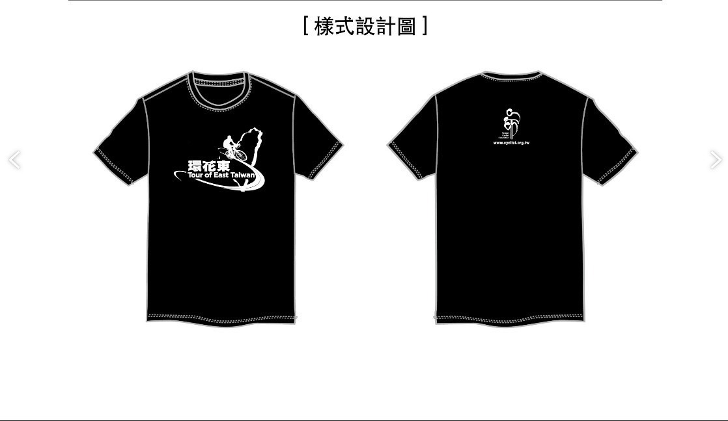
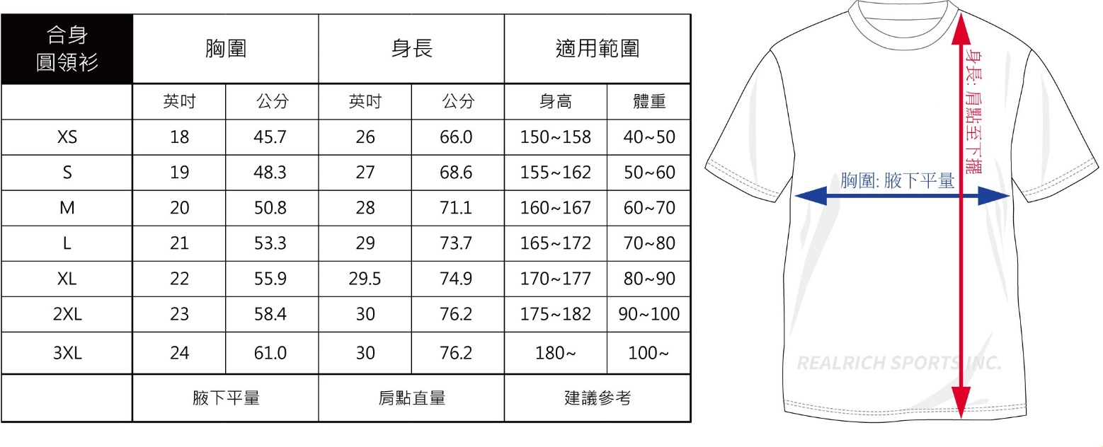

活動紀念小帽 Event Cycling Cap

