2024 Tour of East Taiwan

**2024 Tour of East Taiwan 210 & 160km Challenge**

The all new 2024 Tour of East Taiwan Cycling Series 210km and 160km Challenge will be held on April 13th ~ 14th.

Instead of the traditionally popular 365km challenge, the new 210 and 160km challenge showcase the scenic East Taiwan in a more essential way! By riding across the coastal mountains you will experience more diversified road profiles, as well as meeting aboriginal tribal towns and cuisine! More relaxed? Not at all! Less distance but with more changes in scenery, the 210km/160km is a more compact yet wonderful cycling challenge!

**Directed by:** Sports Administration, Hualien County Government, Taitung County Government.

**Organizer:** Taiwan Cyclist Federation, Hualian County Athletics Federation.

**Date:** Apr.13th ~ 14th, 2022 (Sat. ~ Sun.)

**Event on-site Check-in:**

Apr.12th, 13:00 – 18:00 at Hualian Pacific Ocean Park.

**Event Briefing:** Apr.12th, 16:00 at Hualian Pacific Ocean Park.

**Event Schedule:**

* **Apr.13th : Hualien –Ruisui.**

06:30~ Sign up & day bag transportation check-in. (Hualien Pacific Ocean Park)

07:00 Start: Hualien Pacific Ocean Park – Hualien Bridge – (Going Hwy No.11 south bound).

11:00 Lunch

210km group / Baxientong parking lot.

160km group / Shalao Tribe.

15:00 Finish and daybag claim - Hotel Mizuho Ruisui Hualien.

16:00 Finish point closed.

* **Apr.14th : Ruisui –Hualien via Taiwan No.9 highway.**

09:00~ Sign up & daybag transportation check-in. (Hotel Mizuho Ruisui)

09:30 Start: Ruisui – (Going Highway No.9 north bound).

10:30~ Lunch / Guangfong Farmers’ Association

15:00~ Finish and daybag claim – Hualien Pacific Ocean Park.

17:00 Finish point closed.

**Event Route (210km):**

4/13: Hualien Pacific Ocean Park – Hualien Bridge – Highway No.11 – Niushan – Jiqi – Fengbin – Changbin(lunch) – Yuchang Highway – Highway 193 - Hotel Mizuho Ruisui. Distance: 139kms.

4/14: Hotel Mizuho Ruisui – Kwangfu(lunch) – Fenglin – Highway No.11C – Hualien Pacific Ocean Park. Distance: 65kms.

**Event Route (160km):**

4/13: Hualien Pacific Ocean Park – Hualien Bridge – Highway No.11 – Niushan – Jiqi – Fengbin – Kwangfeng Highway – Highway 193 – Taibalang – Shalao Tribe(lunch) - Hotel Mizuho Ruisui. Distance: 95kms.

4/14: Hotel Mizuho Ruisui – Kwangfu(lunch) – Fenglin – Highway No.11C – Hualien Pacific Ocean Park. Distance: 65kms.

**Rider Qualifications:** Experienced riders able to cover long distance.

**Entry Fee:** A-NT$2,500 per person; B-NT$4,000. A refundable chip deposit NT$500.

**Event Souvenir: A-**Event shirt, cycling cap, bike plate, 2 finisher medals, day bag, digital finisher certificate, lunch, timing chip and number patch, feeding stations, basic insurance, day bag transportation and recovery vehicle service.

**B-**All items in A, plus event jersey(MSRP NT$2,500).

**Optional order items of hotel reservation, and event souvenirs:**

* Hotel rooms for 4/12 in Hualien and 4/13 in Hotel Mizuho Ruisui. 4/13 hotel room fare in Taitung includes dinner / breakfast.
* Lion Travel Event Accommodation Package including railway return tickets starting from Songshan Station 10:30 on 4/12.( 365km組有寫雄獅套裝，210/160沒有？)
* Event souvenirs including jersey and T-shirt.

These optional items could be purchased via the registration webpage.

**Timing Chip Deposit:**

NT$ 500 per person (Deposit to be pre-paid in event registration. To be refunded when returning the chip at the finish. NT$1,000 penalty for each chip lost.)

**Categories:** All types of bicycles

1. M15 – Age 15~19 ( 2005 – 2009）
2. M20 – Age 20 ~ 24（2000 – 2004）
3. M25 – Age 25 ~ 29（1995 – 1999）
4. M30 – Age 30 ~ 34（1990 – 1994）
5. M35 – Age 35 ~ 39（1985 – 1989）
6. M40 – Age 40 ~ 44（1980 – 1984）
7. M45 – Age 45 ~ 49（1975 – 1979）
8. M50 – Age 50 ~ 54（1970 -1974）
9. M55 – Age 55 ~ 59（1965 – 1969）
10. M60 – Age 60 and above（ ~1964）
11. W35 – Female Age 35 and under（1989 ~ 2007）
12. W36 – Female Age 36 and above（ ~ 1988）
13. Pedalec（Electric-assisted）: no age and gender limitation.

**Registration:**

* **Online registration by visiting** [www.cyclist.org.tw](http://www.cyclist.org.tw)and clicking onto the event registration page. Online registration ends on Mar.10th.
* **Payment:** Following the registration webpage instruction, you may proceed to the credit card payment. For any order change, please kindly email us via [service@cyclist.org.tw](mailto:service@cyclist.org.tw) before Mar.10th. From Mar.11th on, any order change will NOT be acceptable.

**Rules and Regulations:**

* + - 1. Riders are only permitted to ride bikes with full braking system. The bicycle must be mounted with front and rear lighting for illumination when going through tunnels.
      2. Riders must wear cycling jerseys and helmets at all times during riding.
      3. Please make sure that your bike is properly maintained prior to the event and remember to bring your personal spare parts.
      4. Please attach your event identification materials as shown below:

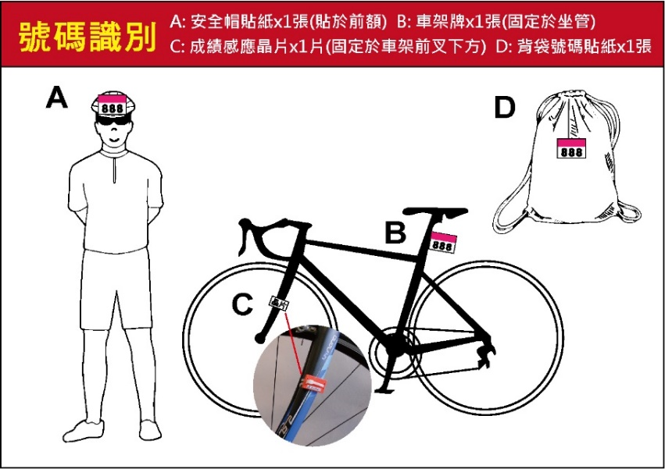

* + - 1. Riders must ride on the right side of road and obey traffic rules. Riding in the wrong direction/lane (left side) is prohibited.
      2. There will be feeding stations every 25~45kms along the route. Riders should slow down and ride to the roadside to approach the feeding zone for taking feeding supplies.
      3. Day bag claim:
* Apr. 13th – Please receive your transported day bag at the Hotel Mizuho Ruisui upon your arrival.
* Apr. 14th – Please receive your luggage at Hualien Pacific Ocean Park.
* Please make sure each piece of your luggage has a clear and easy-to-read luggage tag for identifying your luggage.
* Please hand over your day bag to the Day Bag Transportation Car in time before you start the riding. Do NOT put valuables or fragile items in the day bag for transportation.
* We recommend you bring just one piece of luggage for the event. DO NOT hand over the hard-shell bike box to the day bag truck.
  + - 1. The rider insurance of this event is Public Liability Insurance, in which any personal health problem during the event or any riding injury caused by personal health problem will not be included in this insurance. Riders are recommended to buy personal health and medical care insurance.
      2. Participants will be covered with the Travel Insurance and the Public Liability Insurance. The Public Liability Insurance covers the accident only that Organizer is responsible for. Each participant should evaluate his/her own safety regarding personal health conditions when deciding whether to participate in his event. Participants should apply for extra personal insurance policy at his/her own cost when considering that the aforementioned insurance is insufficient. Please refer to the Insurance Policy Website for the coverage details of the [Travel Insurance](http://www.cyclist.org.tw/upfile/file/20181225/20181225115141134113.pdf) and the [Public Liability Insurance](http://www.cyclist.org.tw/upfile/file/20181225/20181225115169526952.pdf). The Organizer is only responsible for the indemnity amount with the maximum payment of claims per person as the insurance policy offers. Do not register the event if you do not agree with the coverage, items, indemnity amount of insurance policy.
      3. According to the Insurance Law, riders under 15 years old would not be compensated with death indemnity under Life or Injury Insurance policy.
      4. For the medical insurance needs, if any hospital medical treatment is caused by an event accident, keep all receipt and diagnosis certificates (issued by a doctor) and give these later to the Taiwan Cyclist Federation for insurance payment application needs.
      5. This event is a physically challenging ride. Riders who have hypertension, cardiopathy, asthma, cardiovascular diseases, diabetes, epileptoid, are not recommended to join this event.
      6. The Organizer has the right to stop riders from riding depending on the rider's health condition at any time before or during the event.
      7. Riders with time chips installed must pass the time recording zone at the Start Point and at the Finish Point for official time recordings.
      8. Depending on the weather or any natural disaster, the Organizer has the right to stop or cancel the event, with regards to concern for rider safety.
      9. Riders shall not dispose of any rubbish throughout the route and event area.
      10. The Organizer has the right to use any reports/articles and images of the event for promotional purposes.
      11. Please watch for any information updates with regards to this event, which will be announced on the T.C.F. website: [www.cyclist.org.tw](http://www.cyclist.org.tw/) & Facebook fans page: [www.facebook.com/tcf1999](http://www.facebook.com/tcf1999).

**Contact: Taiwan Cyclist Federation**Tel：+886-2-8919-3595 Fax：+886-2-8919-3311 E-Mail：[service@cyclist.org.tw](mailto:service@cyclist.org.tw)   
Website: [www.cyclist.org.tw](http://www.cyclist.org.tw/) Address: 1F, No.17, Lane 100, Chungxing Road Section 2, Xindian District, Xinbei City 231, Taiwan (R.O.C.)

Remark: the design is for reference and subject to change.

[ **Feeding Station schedule ]**

**210km Challenge**

|  |  |  |  |  |
| --- | --- | --- | --- | --- |
| Date | No. | Spot | Location | Accu. Dist. |
| 4/13 | 1st | Jiqi Beaches | Hwy No.11-37K | 36.7 |
| 2nd | Baxiandong Parking lot / Beach Restaurant (Lunch) | Hwy No.11-77K | 75.6 |
| 3rd | Antong Hot spring | Hwy No.30 | 112.5 |
| 4/14 | 1st | Kwangfong Farmers’ Association (Lunch) | Hwy No.9-235K | 22.2 |
| 2nd | Fude Temple | Hwy No.11C-16.5K | 44.3 |

**160km Challenge**

|  |  |  |  |  |
| --- | --- | --- | --- | --- |
| Date | No. | Spot | Location | Accu. Dist. |
| 4/13 | 1st | Jiqi Beaches | Hwy No.11-37K | 36.7 |
| 2nd | Shalao Tribe (Lunch) | Hwy 193 | 67.6 |
| 4/14 | 1st | Kwangfong Farmers’ Association (Lunch) | Hwy No.9-235K | 22.2 |
| 2nd | Fude Temple | Hwy No.11C-16.5K | 44.3 |

**Route Map – 210km**

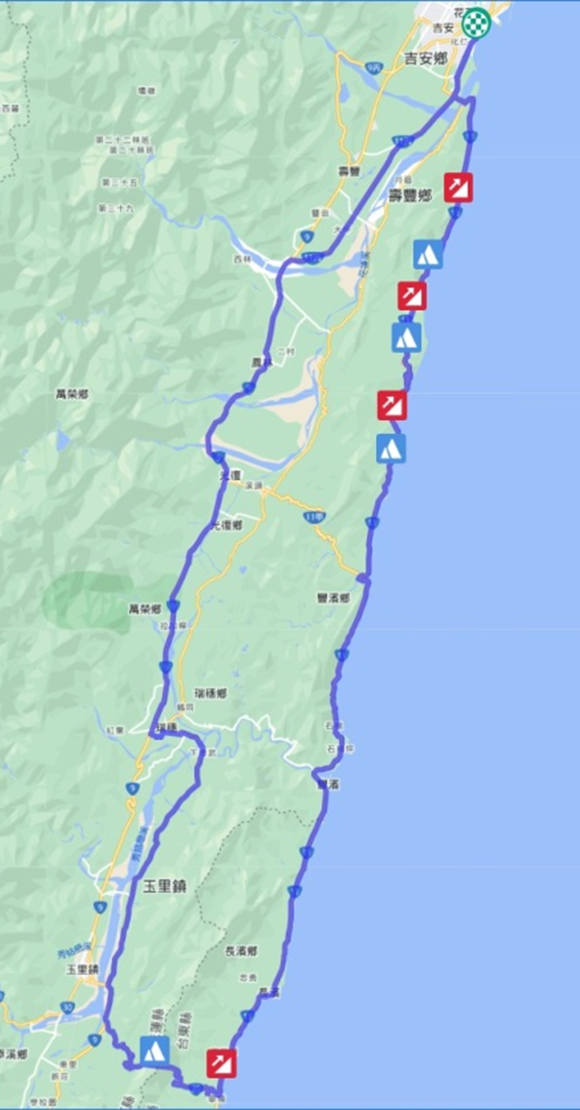

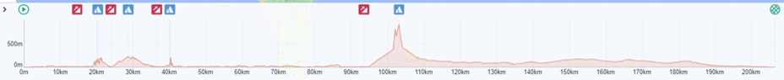

**Route Map – 160km**

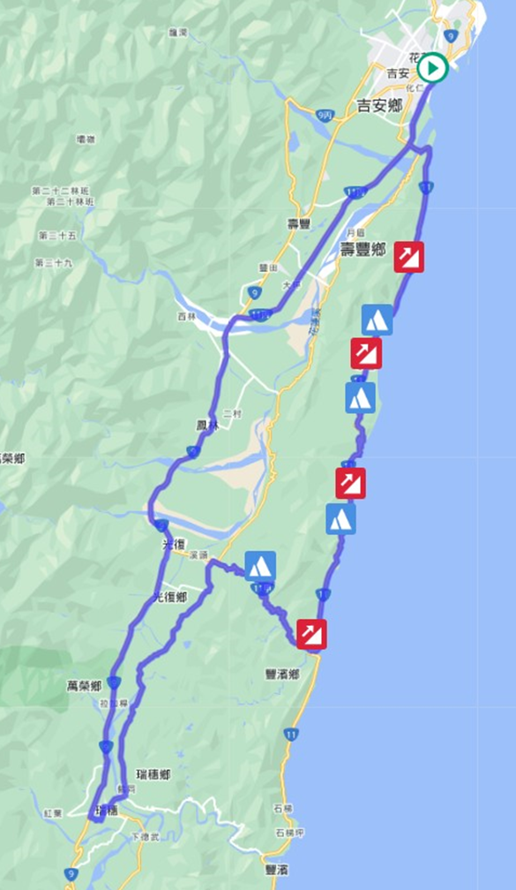

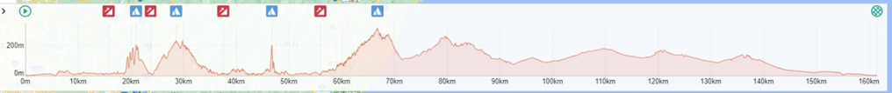

**Event Souvenir - Shirt**

**活動贈品：紀念衫示意圖Event Souvenir - Shirt**

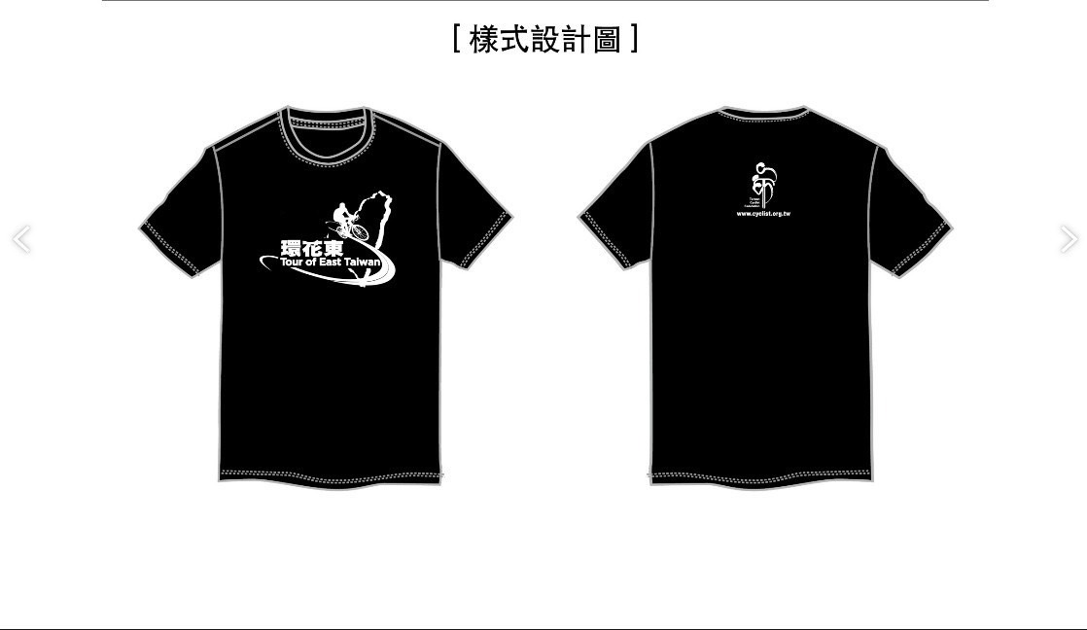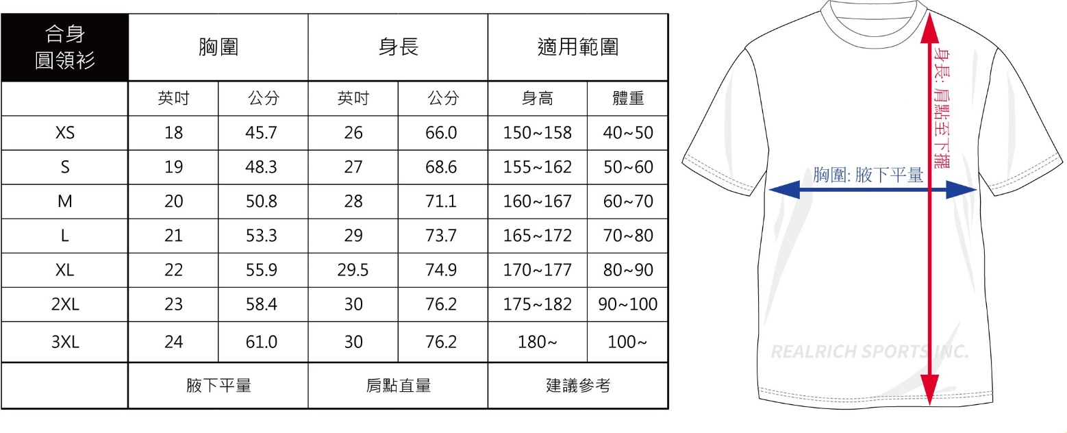

**Event Souvenir - Cycling Cap**



**Event Souvenir – Cycling Jersey : Special Offer NT$1,200 (MSRP NT$2,500)**

